**Import Data From S3 To Dynamodb**

**Architecture**

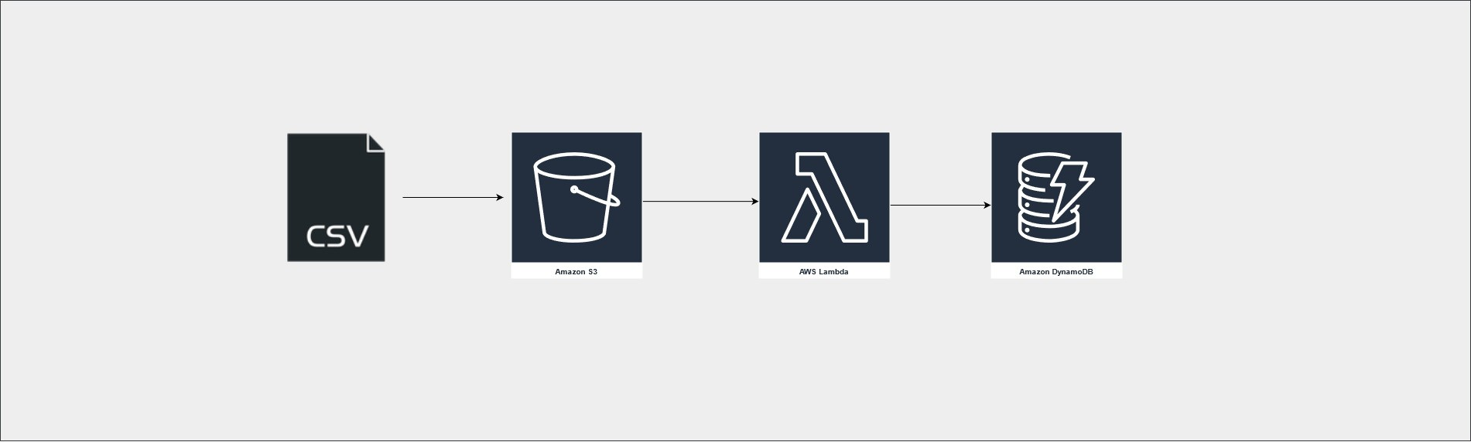 **User(csvfile) S3 Lambda Dynamodb**

**Steps for implementation to this project:**

**1. Create a Amazon DynamoDB table:**

* On DynamoDB Dashboard Tables / Under Create table  Name the table Partition Key : ID,Type :String Create Table

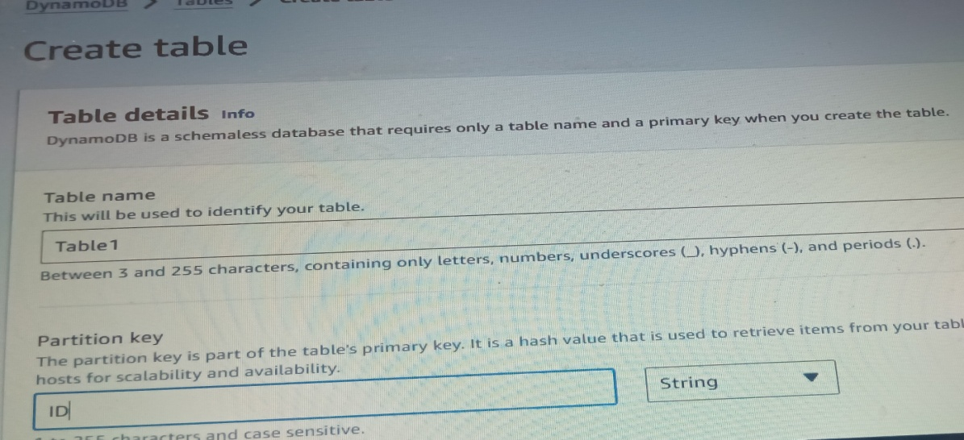

**2. Create an S3 bucket**

* On Amazon S3 Console /Create bucket Name the bucket. Create bucket.
* Upload a CSV file to the bucket. (Under S3 bucket that we have created Objects Upload / Under Upload, For Files and folders / Add files)

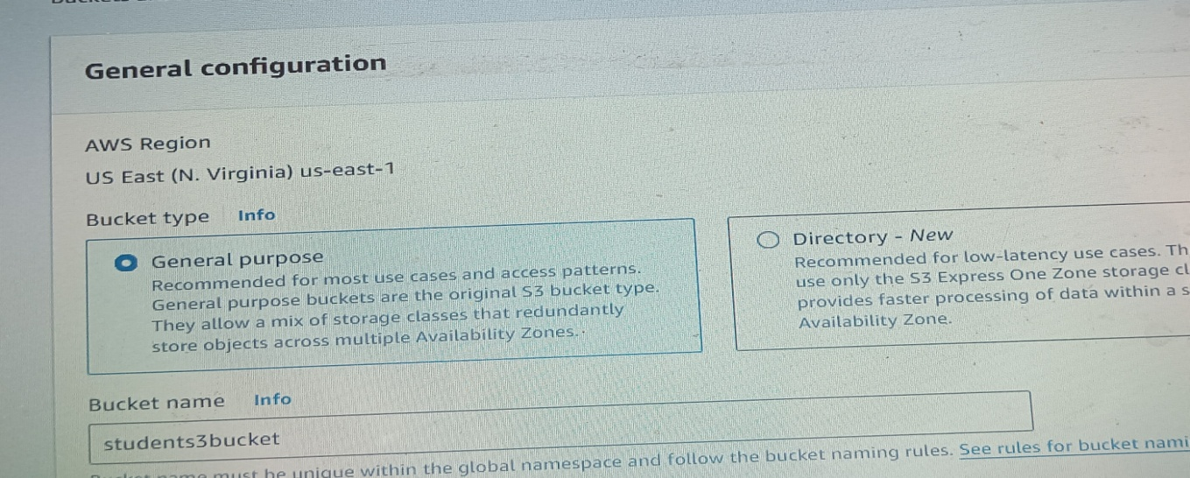

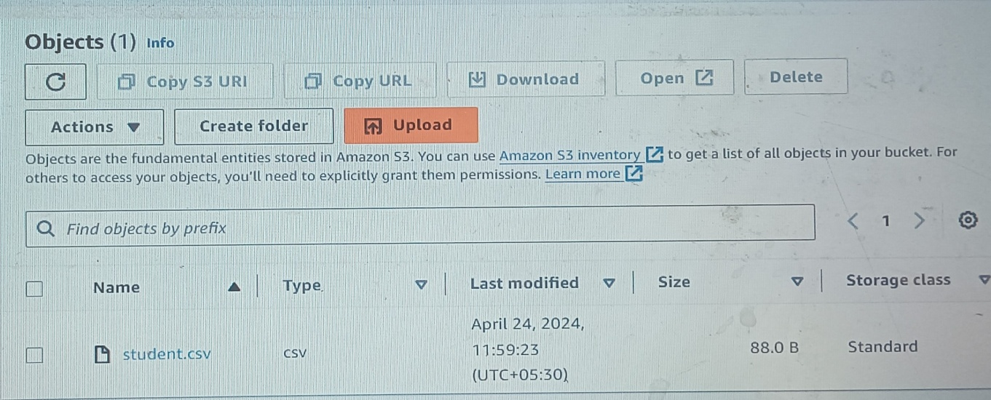

**3.IAM Role**

* On the IAM dashboard / Roles Create Role AWS service Use case / Select Lambda Add permissions( Give S3 full access,and DynamoDB full access) Name the role Create role.

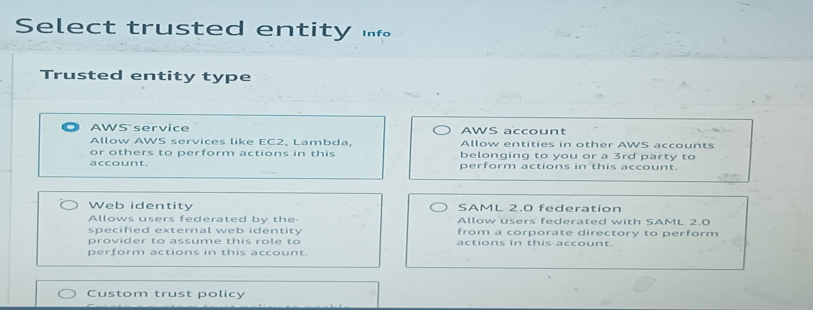

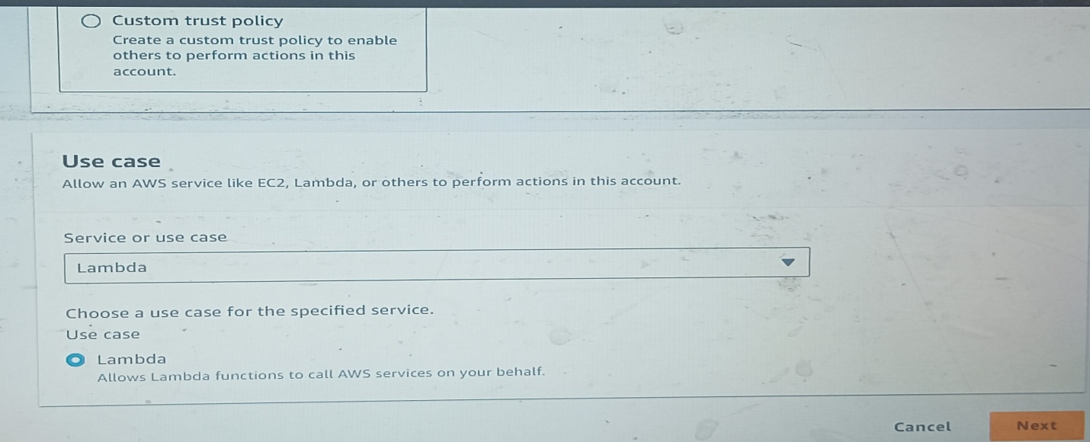

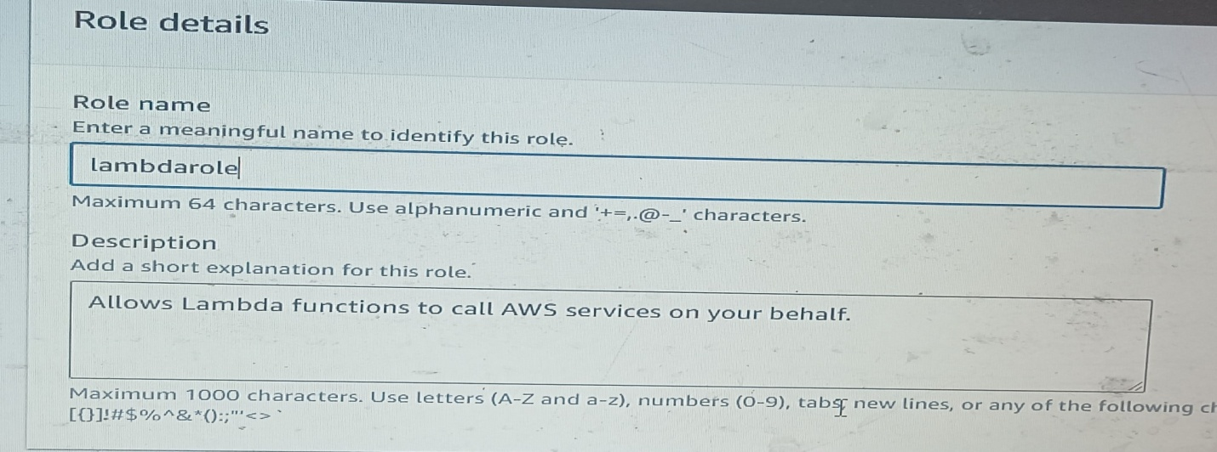

## 4. Creating Lambda Function

* On the Lambda Console / Functions. Create function / Select Author from scratch Name the function Runtime/Python 3.9
* Click on Change default execution role / select Use an existing Role / Select the role we have created just now . Create function.
* Once the function is created, it will open the main page of the Lambda function. Code Change the code with new code. Update the Dynamodb Table name After updating the code, click on **Deploy** button to save the code.

( Also in the code , under table, check the partition key that is ID ‘id’ or ‘ID’)

* Change the function timeout as follows:

**.** Navigate to the Configuration  click on General configuration / click on Edit  In the Edit Basic setting **/** change the Timeout value to 1 min

Click on Save button. **For code refer “source code”.**

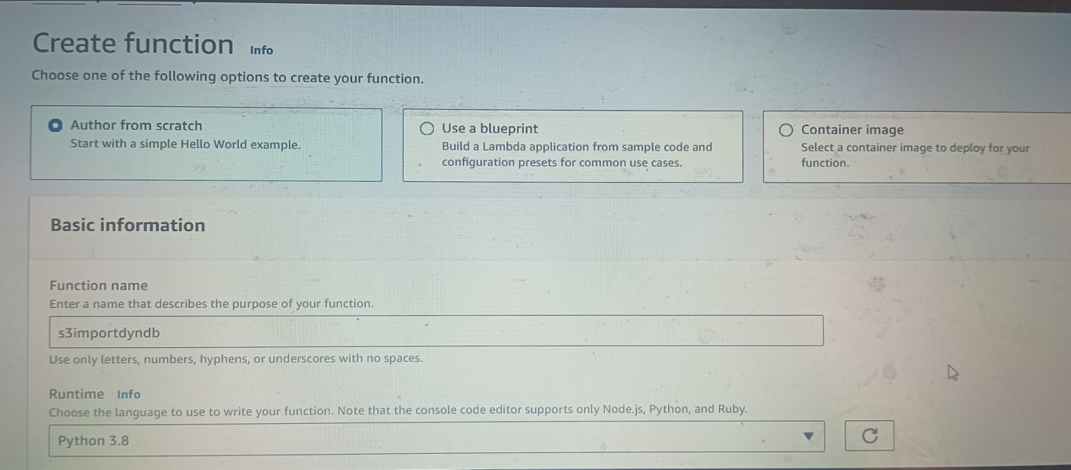

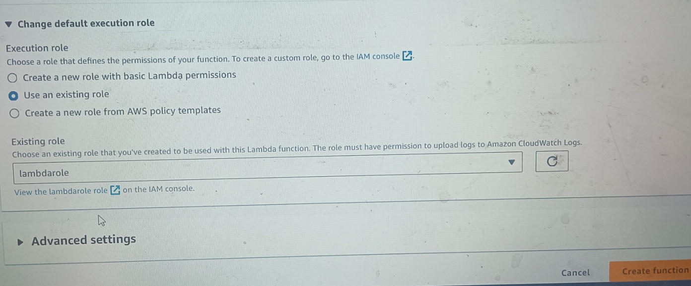

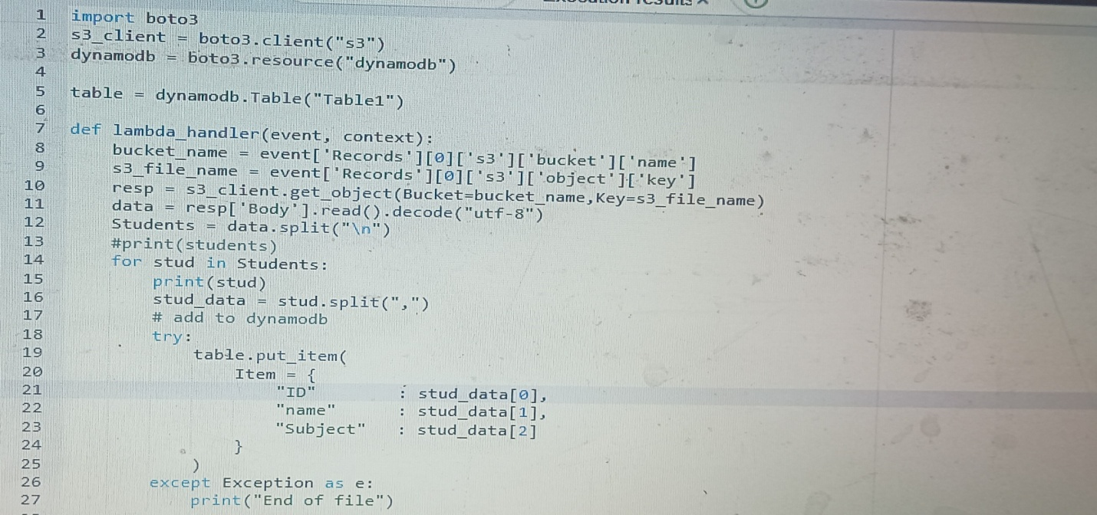

Dynamodb Table name

Dynamodb partition key “ID”

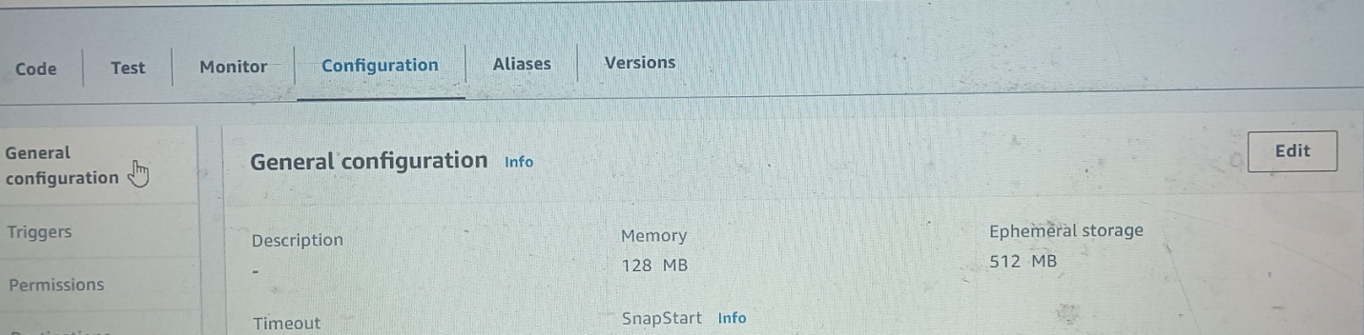

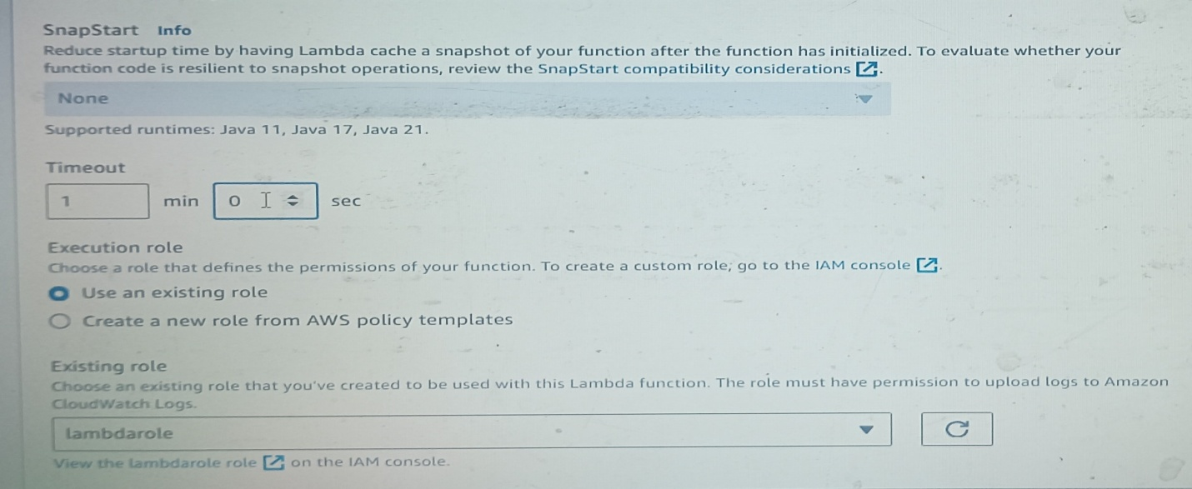

## 6. Test the CSV Data Import in Lambda:

* In the  function page, click on the Test tab. Configure to test event Name the event Template **/** Select Amazon S3 Put Below in the JSON code:**Update the S3 bucket name,bucket ARN and key (CSV file name).**
* Save the changes.
* Click on Test  to trigger the lambda function.
* Once the lambda function is successfully executed, you will be able to see a detailed success message with table data.
* Go to the DynamoDB table and then select the table and click on Explore Table Items

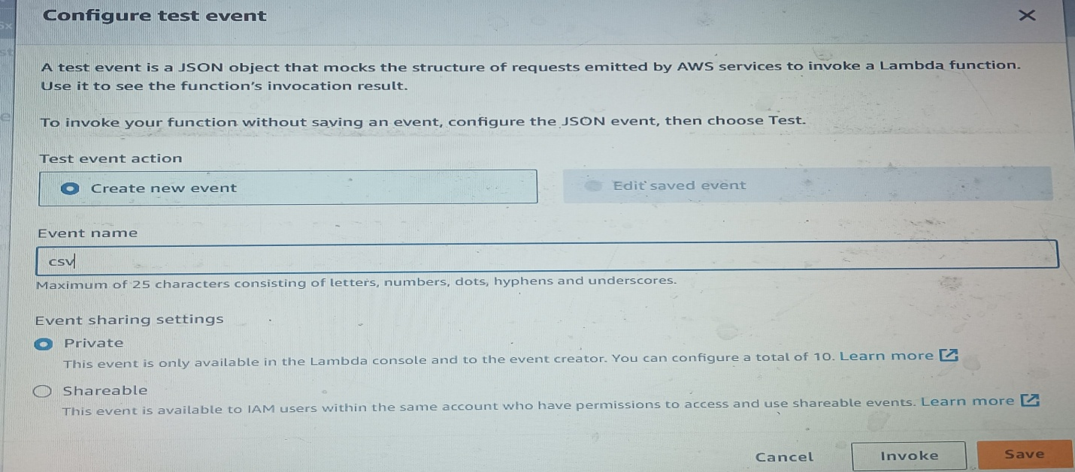

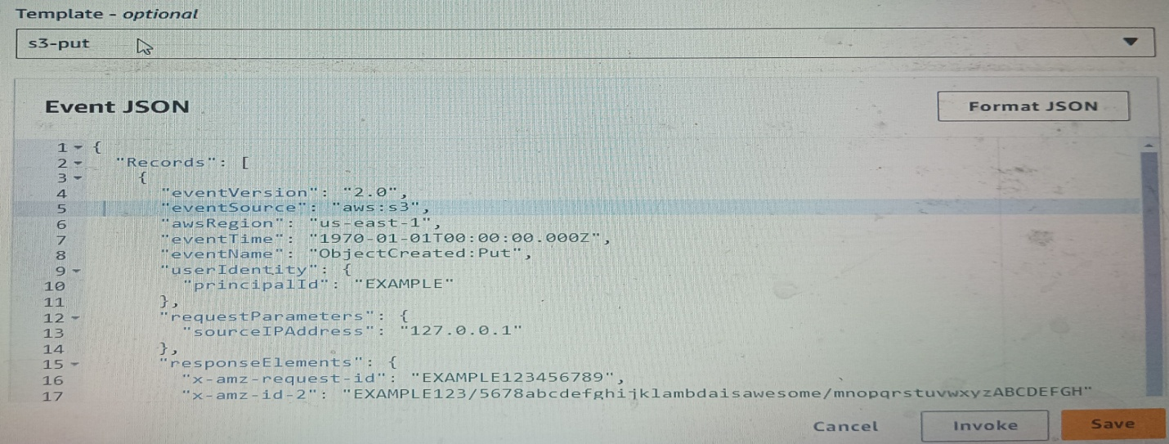

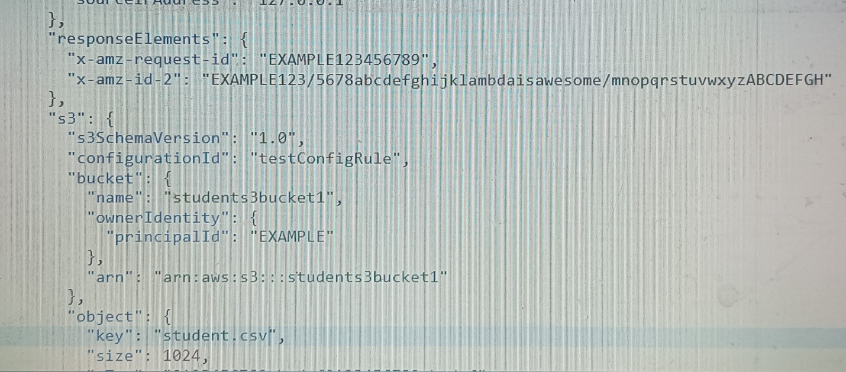

CSV file name

S3 bucket ARN name

S3 bucket name

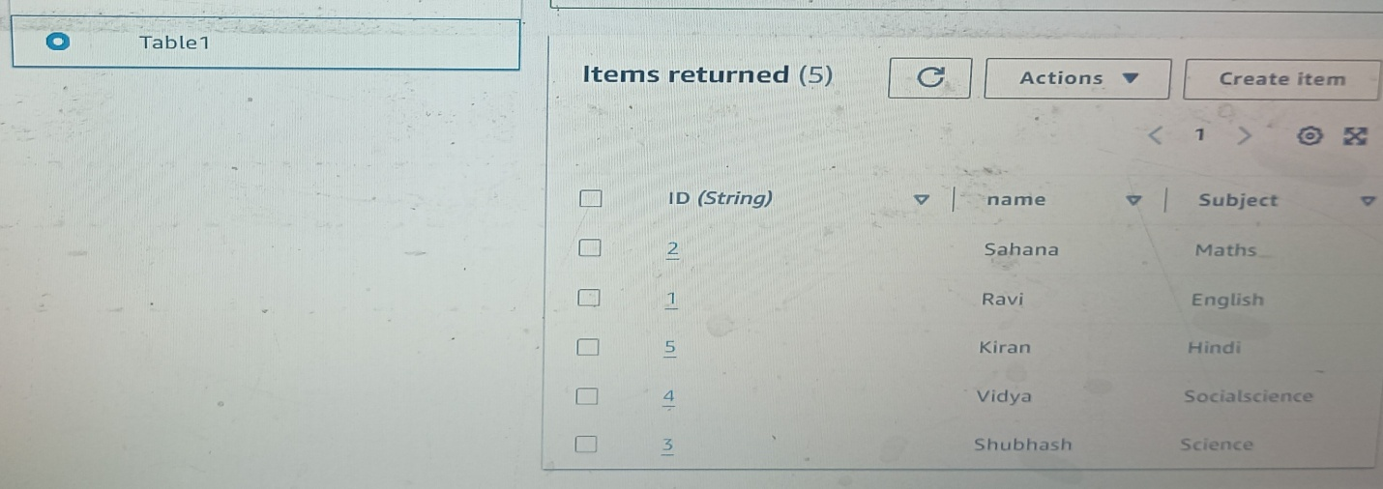

## 7. Adding Event Triggers to the S3 Bucket to call our Lambda function whenever new data arrives.

## On the S3 Console / Click on the s3 bucket Click on the Properties tab Event notifications / create event notifications

## Name the event Suffix(.CSV) Select Event Type(All object creation)

## Choose the destiantion / Lambda function Choose th Lambda function that we have created. Save changes.

* Now every time a CSV file is uploaded to our S3 bucket, it will trigger the lambda to import the CSV data into the DynamoDB table.

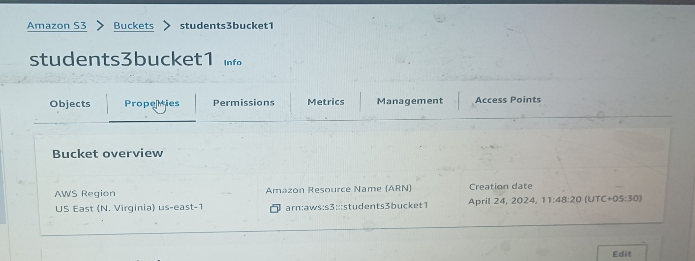

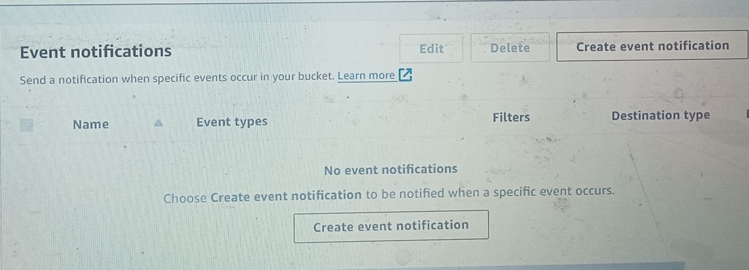

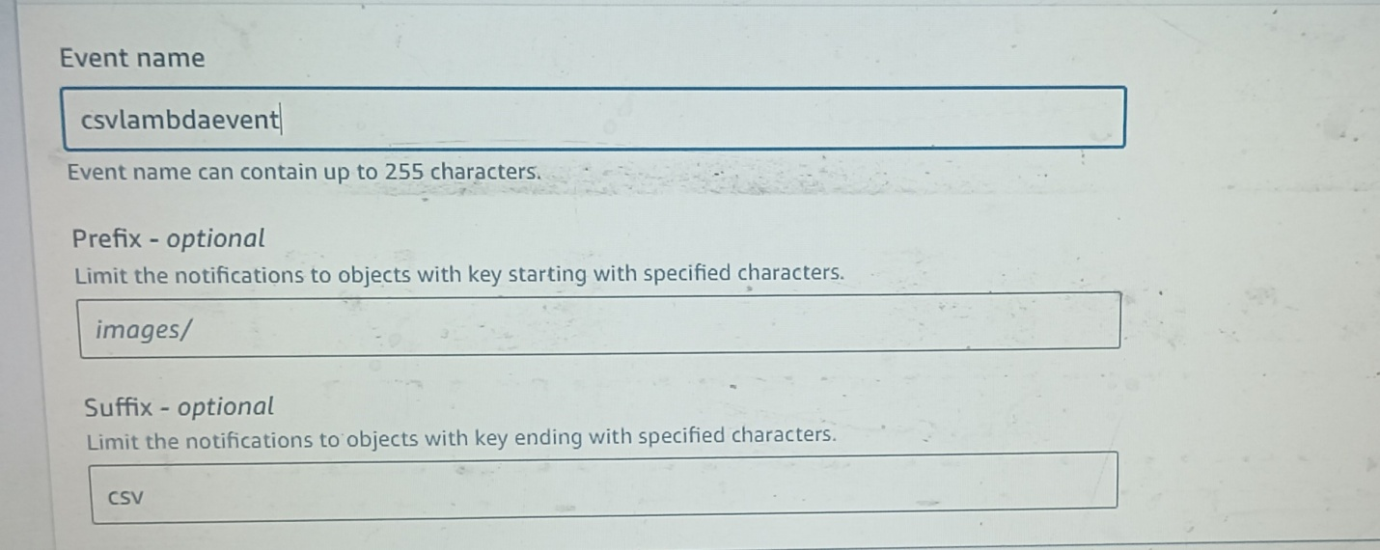

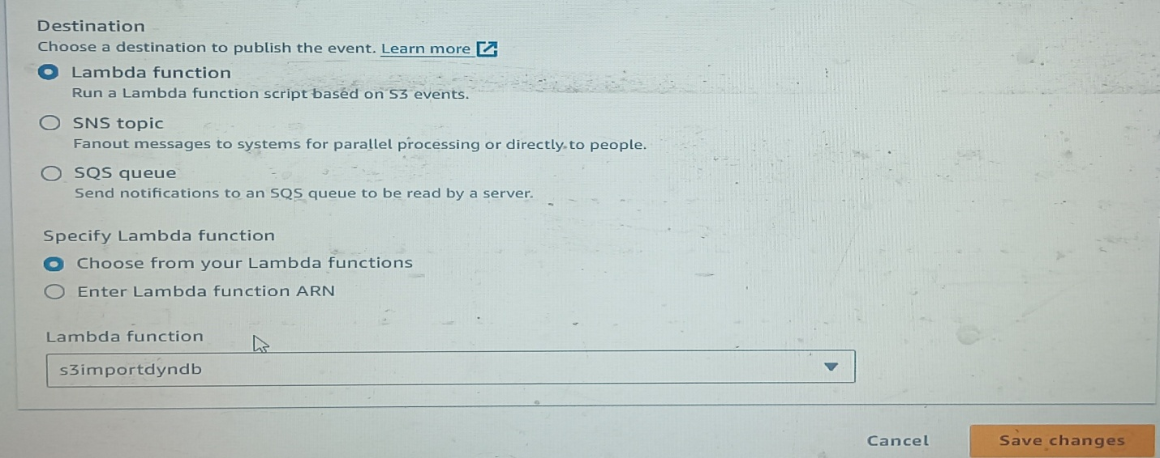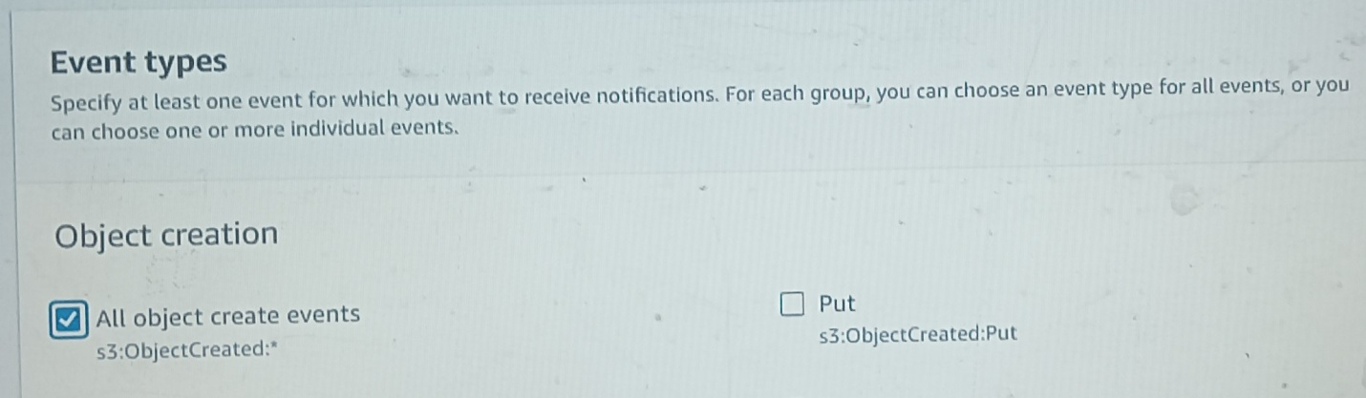

**8. Test the setup**

## Upload a new CSV file (student1.csv) to S3. This upload event should triggered our Lambda function to import the CSV data into the DynamoDB table.

## Go to the DynamoDB table to see the changes.

* Click on the refresh button if items have not yet changed.
* You can see that new CSV data has been successfully imported into the DynamoDB table.



 